Samsung Innovation Capmus

**Facilitators:**

**Nadeen Essam - Ahmed Hatem**

**Author:****[Akram El-Raey-Ahmed Wael-Eyad Elfar]**

#### Night Light Automation System

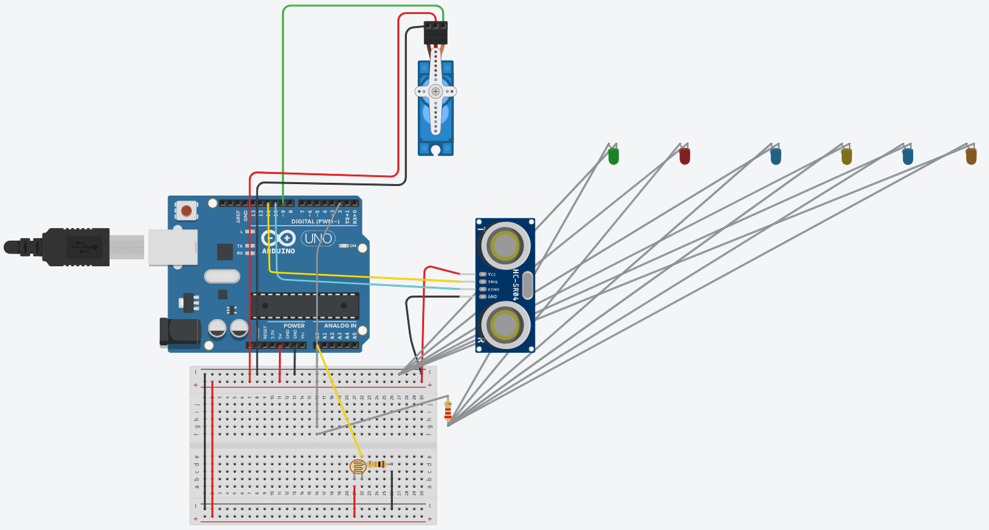

At the beginning, we have ( Servo motor , Ultra Sonic sensor , LDR , LEDs , ARDUINO , Resistors , breadboard) , we fixed the ultrasonic sensor above the servo motor gear with double-faced tape ,

And we made the servo motor moves in ( 180o ) and checks if there is an object in front of it , if there is an object , it will check if the LDR reading is more than or equal (700) (depends on the type , resistance , connection type).

If the LDR reads less than (700) and an object is caught at less than (100 cm) , the LEDs will light up ,

If no object is caught (in 100 cm) range or the light is already turned on (more than 700 in my connection device) , the LEDs won’t turn on.

#### 1.1)Night Light Automation System (updated)

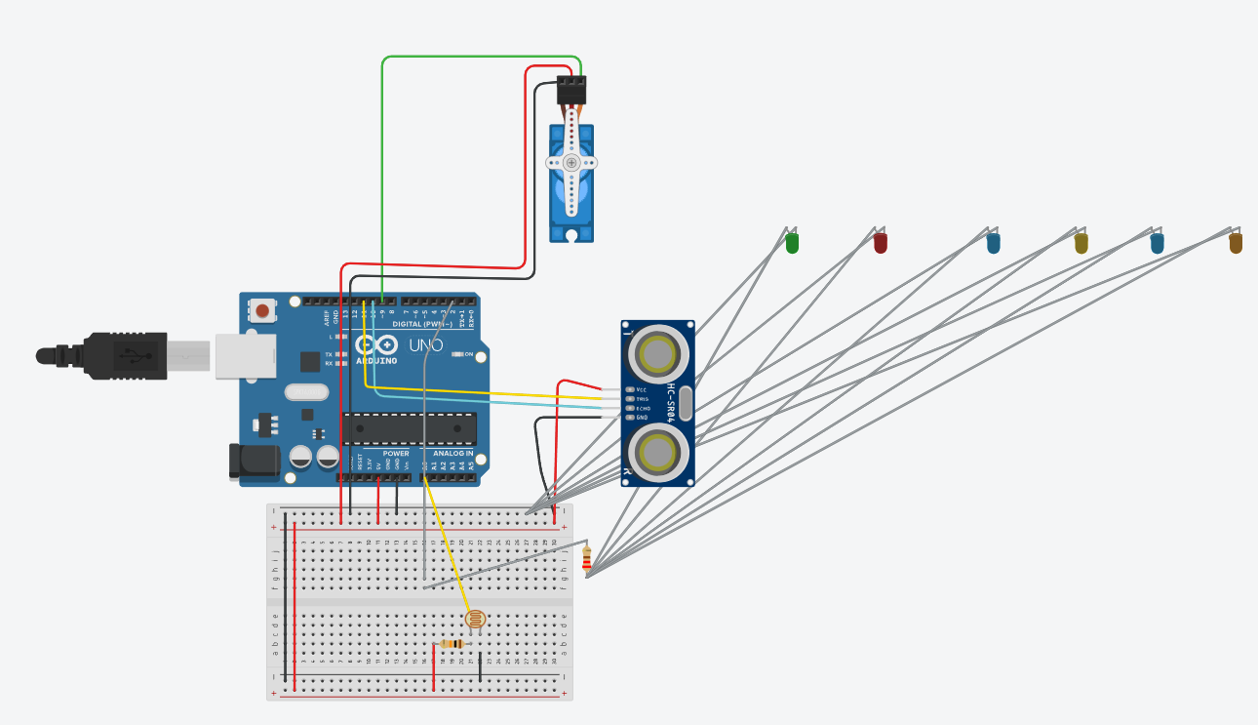

Same as the last night light system , but with a little change we made the Ultrasonic sensor stops when some one moves in , and stop checking until the object moves away again

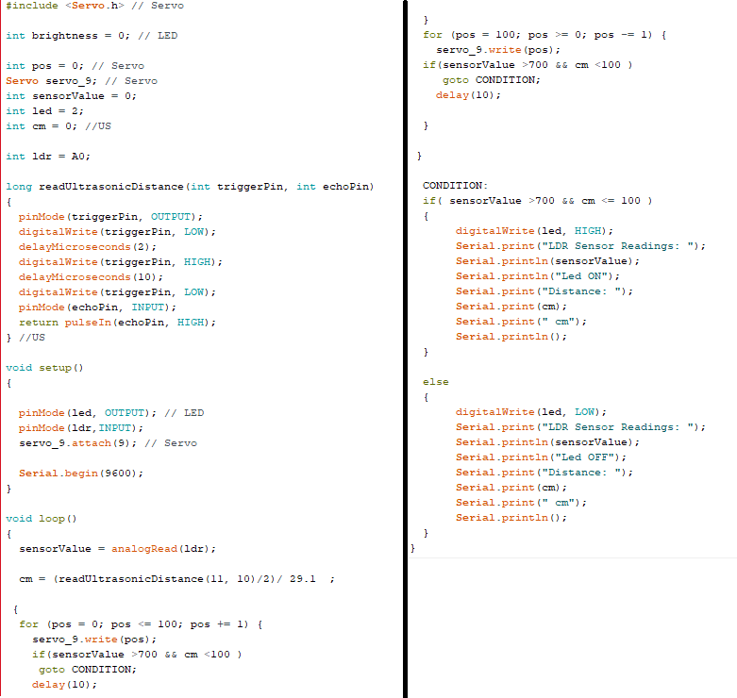

#### Home Gate Automation System

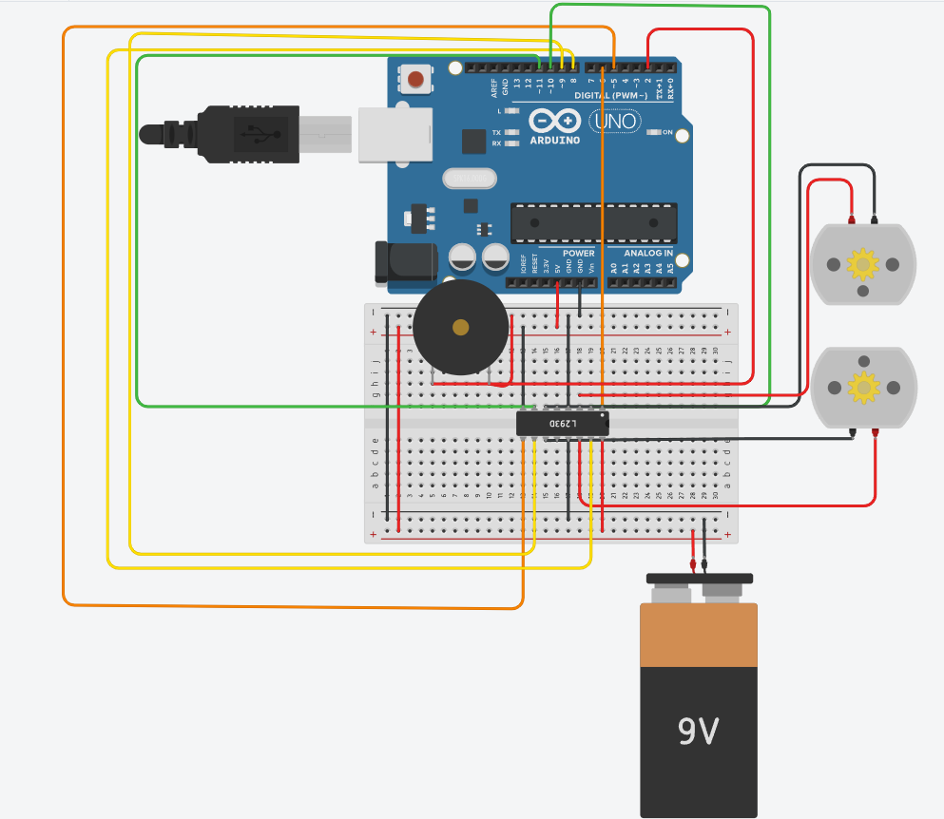

At this system, we have ( 2 DC motors , Piezo (Buzzer) , H-Bridge , 9v Battery, ARDUINO , breadboard, 2 switches (didn’t found them in tinker cad)) , we made each motor facing the other, because we want the gate to be opened in same direction like the picture above , then we have switch that buffer the motors with energy , and a switch that rings the bell , when we the bell is rang , we can open the door by closing the circuit of the motor , the door opens 2 seconds and then it will be closed again.

